HTML Customization Instructions
Page Vectors – Create multiple forms to direct different groups of requesters to custom pages.
- Retrieve the following pages from the application: request.html, request_bldg.html, request_form.html, f_bot_toc.html, and f_bot_main.html.
- Copy the following pages for each group that will be submitting requests:
  - Request.html (facility selection page)
  - Request_bldg.html (building selection page)
  - Request_form.html (request form page)
- Rename each form to identify easily such as maint_request.html for facilities and fleet_request.html for fleet.
- Open the maint_request.html page and add the vector code to point to the correct building request form.

<form method="POST" action="/facility_select.cgi" enctype="x-www-form-encoded">

After this line of code enter:
<input name=”pagevector” type=”hidden” value=”maint_request_bldg.html”>
Notice that we point to the building selection page in the code.
- Open the request_bldg.html page and add the vector code to point to the correct request form.
<form method="POST" action="/building_select.cgi" enctype="x-www-form-encoded">
After this line of code enter:
<input name=”pagevector” type=”hidden” value=”maint_request_form.html”>
- This will need to be done for each group that needs their own forms.

Hyperlinks – this will direct requesters to a specific form depending on the type of request.
- Using FrontPage, open the f_bot_main page and enter text in the body of the form in the Normal tab with instructions such:

“Click on one of the links to submit a request:”
“Maintenance”
“Fleet”
- Highlight the hyperlink word and right mouse click and choose the Hyperlink option. Enter the path in the URL field to the page that you want to direct requesters (/maint_request.html) and click OK. Continuing adding a hyperlinks to direct requesters to the proper form.

Bypass Facility Select Page – this will allow requesters to bypass the facility selection page if there is only one facility.
- Open the maint_request.html page and add the vector code to point to the building request form.

<form method="POST" action="/facility_select.cgi" enctype="x-www-form-encoded">

After this line of code enter:
<input name=”pagevector” type=”hidden” value=” request_bldg.html”>
- Open the request_bldg.html page and add the vector code to point to the request form.
<form method="POST" action="/building_select.cgi" enctype="x-www-form-encoded">
After this line of code enter:
<input name=”pagevector” type=”hidden” value=”request_form.html”>
- Open the request_bldg.html page and hard code the facility ID code as the default. You will see the following code at the top of the page. Enter the facility ID code after the DataValue. See example below in red:
<meta http-equiv="Content-Type" content="text/html; charset=iso-8859-1">
<meta name="GENERATOR" content="Microsoft FrontPage 4.0">
<meta name="ProgId" content="FrontPage.Editor.Document">
<!-- DataProc: FetchBuildingMenu //-->
<!-- DataValue: ‘Facility ID Code’ //-->

- Open the f_bot_toc.html page using FrontPage and highlight the Submit a Request hyperlink found on the normal tab. Right mouse click on the link and choose hyperlink properties. In the URL field map the path to the request_bldg.html page (/request_bldg.html) and click OK to save.
- Another option if you don’t have FrontPage is open the f_bot_toc.html page and find on request.html and replace it with request_bldg.html.
Now when you click on Submit a Request, you will be at the building selection page.
Hardcode Repair Center – this will lock a repair center in so requesters won’t have to choose one.
- Open the request_form.html page and find the following code:
<form action="/request_submit.cgi" enctype="x-www-form-encoded" method="post" name="RequestForm">
<input type="hidden" name="Request Type" size="20" value="WEB">
<input type="hidden" name="Building" size="20" value="BLDG_DEF_KEY">
<!-- <input type="hidden" name="Requester IP Address" size="20" value="HOSTIPADDRESSKEY"> //-->
<!-- <input type="hidden" name="Authenticated User" size="20" value="ISD_AUTHUSER_KEY"> //-->
<input type="hidden" name="LOG_RQ_FK" size="20" value="LOG_RQ_FK_KEY">

Add the following line of code below the LOG_RQ_FK code:

<input type=”hidden” name=”LOG_RC_CODE” size=”20” value=”PP” - replace PP with the repair center code.

- Next, add the repair center code between the >< in the sample below.

<td width="43%" height="18" class="body" align="left"><font color="#FF0000">*</font>FW_RC_KEY:&nbsp;</td>
<td width="77%" height="18"><select name="LOG_RC_CODE" size="1" width="45">
<option selected>PP</option>
RC_LIST_KEY
< /select>&nbsp;</td>

- Remove the code that makes the repair center required.

xField = test.Log_RC_Code.options[test.Log_RC_Code.selectedIndex].value;
if (xField.length==0) {
alert("Please select a FW_RC_KEY");
return false;

- Another option is to open the request_form.html page using FrontPage and delete the repair center row to remove the field or right mouse click on it and choose the Form Field Properties. Highlight the line item and click the Modify option and add the repair center code in the Choice field and click OK to save.

Making Fields Required
Making fields that not required required is done using code that is already in place and will return an error message. The request form is the most common page that is used to make fields required. Retrieve the request_form.html page from the application. Using code that is already in place, you can copy existing code, paste it, and then change the field name to reflect the new field. You will also need to change the error message. See sample.

The account number field has been added to the error messages found at the top of the request_form page. Copy an existing message, such as the phone # message, and paste it in the sequence where it appears on the form. Next you will need to change the field name to reflect the new field. To find out the name of the field, find the code on the page for that field to determine the field name.
Code used to make a user defined field required:
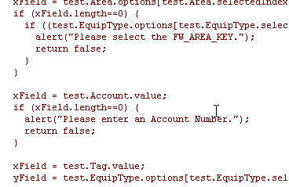
Below is the code used to determine the field name. There cannot be a space in the field name and you will need to change the font to add the asterisk.
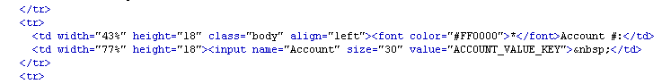

The department has a pick list so, to make the department field required, we need to copy code that also has a pick list such as the repair center code. Copy the existing repair center code and paste it in the sequence where it appears on the form. Make sure to change the field name to reflect the new field. To find out the name of the field, find the code on the page for that field to determine the field name . See sample below.

Code used to make a field with a pick list required:
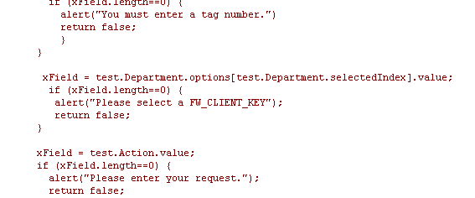
Below is the code used to determine the field name. There cannot be a space in the field name and you will need to change the font to add the asterisk.

Save the changes to the page and test.

